The **FizzBuzz Soda Company** has been a pioneer in the beverage industry for the past decade. Over the years, **FizzBuzz has expanded its reach to over 100 stores** and remains committed to refreshing the world with its effervescent drinks. In order to boost its sales and enhance its market presence, **the company has recently launched a series of promotional campaigns across its stores**.

You've been given access to the sales (sales.csv) and promotion (promotion.csv) **data for the past year.** Your task is to unravel the story behind the numbers and **determine the success of these promotions.**

📁 Data Files:

To start this analytical quiz, you'll primarily be working with two essential datasets:

sales.csv 🛍️: This file **contains the monthly sales data for our beverages across the 100 stores**. It's the heartbeat of our operation, reflecting every bottle sold.

promotions.csv 🎉: This dataset captures the **details of each promotional campaign FizzBuzz rolled out during the year**. It's the key to understanding the strategies we employed to boost our sales.

Both these files are pivotal in answering the next questions and deriving actionable insights. Ensure you familiarize yourself with their structure and contents before diving into the analysis.

Quiz Questions:

Monthly Analysis:

In which months were the promotions executed?

**In September applied 15 Promotions, almost the double than March and December, unique months that promotion were release.**

ROI Examination:

Based on the provided data, which promotion type - "PromotionA" or "PromotionB" - yielded the highest ROI?

**ROI = [ Net Return / Cost of investment] x 100**

**ROI = [(SALES – PROMOTION SPENT) / PROMOTION SPENT] x 100**

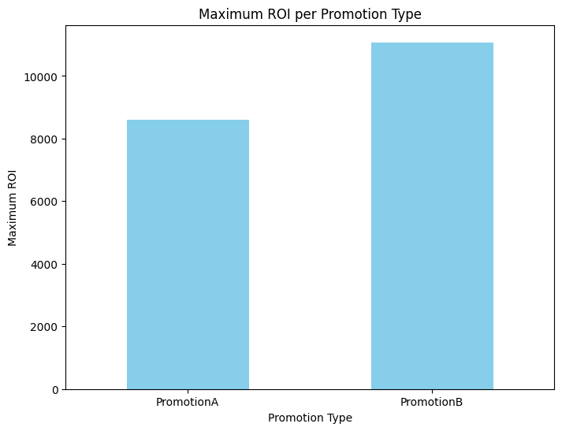

**We got the highest promotion ROI in B Type with 11,076 %**

In your analysis, specify the months and stores where these promotions were most successful.

**March was the month of we got highest ROI’s values, we got better ROI in Promotion B through all these months.**

**Related to Stores, we got the highest ROI in Store 31 for Promotion B and Store 25 for Promotion A.**

Future Insights:

If you were to optimize the promotions for a better ROI in the upcoming year, what strategies or changes would you suggest?

**We can notice than in all the TOP stores sales applied promotions A or B and they got highest sales.**

**In these stores we got worst sales, in all of them they were not apply any promotion.**

**We could identify if we applied promotions for the worst store sales, we can get the triple of benefits, specially If we applied A type promotion.**

**For all the 100 stores, the promotions were applied to 15 stores, 15% of all stores. For Next year, before assigned Promotions we can focus on:**

* **Additional to 15 stores, identify stores without promotion that are getting highest sales with the historical data.**
* **Promotion B is getting better results, we can focus on Promotion A and identify opportunity areas that we can improve results.**
* **Identify products with more highest sales across all the year, It will help to impact more directly on highest sales.**
* **Segmentation of market with historical data applying unsupervised learning like K-MEANS.**

Additionally, what further information or data would you need to make a more informed decision regarding the promotional strategies?

**Adding more variables to our data we must give us a better understanding of sale behaviour and also work more precisely for future promotional strategies, customer analysis and special trends.**

**Additional information:**

* **Variety of beverage**
* **Customer feedback / preferences**
* **Competitor results**

Would giving you the cost of the bottle plus what the bottle would be sold for affect your analysis and how?

**Giving both variables will give us more information about our profit margins and evaluate how promotions are being benefit to the ROI. Also we can make more informed decisions about other commercial strategies.**

After you have answered all questions and are ready to submit your analysis. Setup a meeting with me and show us the analysis you have done on open collab or a python notebook. We will ask you probably some questions and go from there.